Here if agent enter correct Url (<https://creditreversalguru.plexif.com/>) then below screen will be displayed

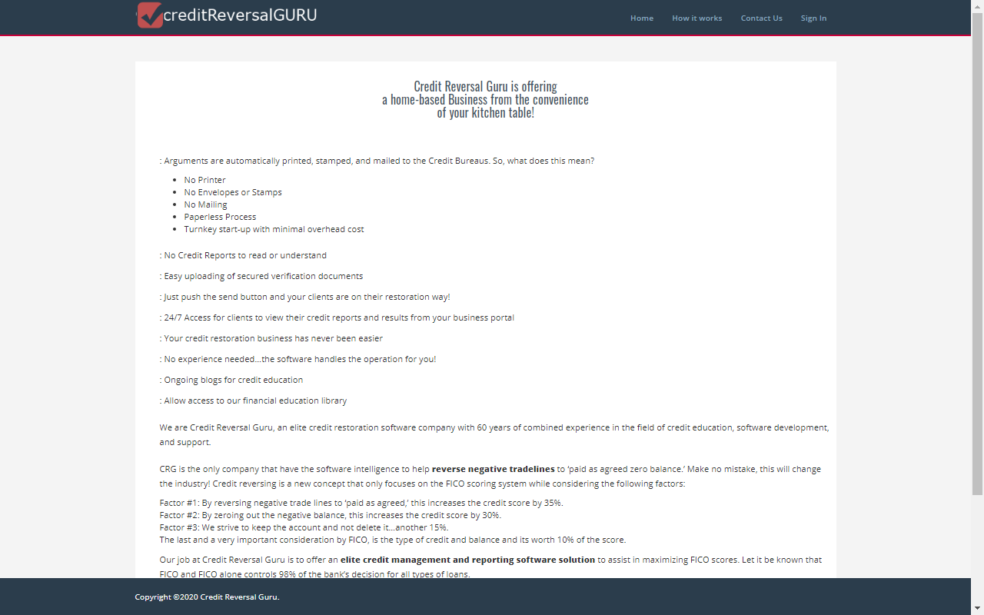

Here in the above screen once agent click Sign in link near header then below sign in screen page will be displayed.

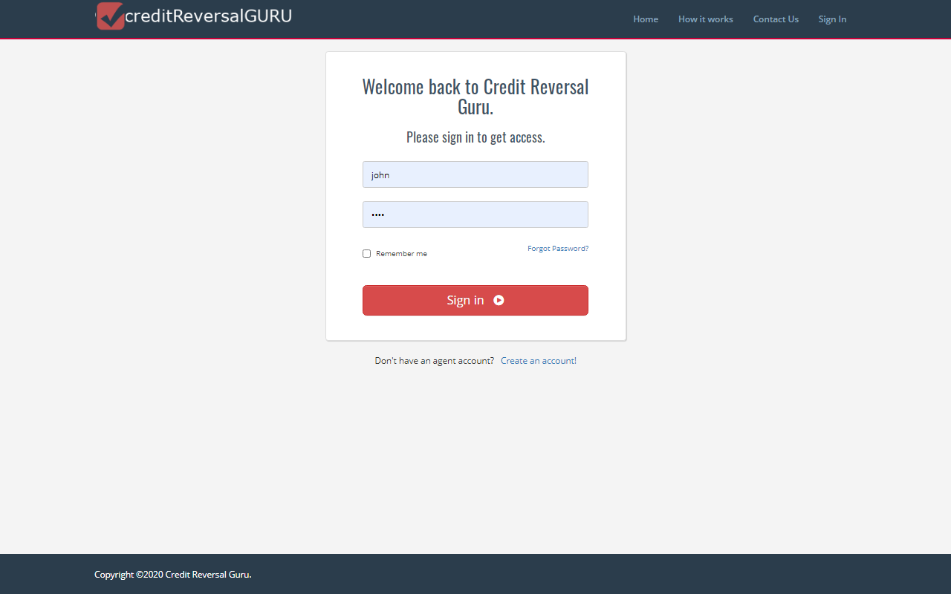

Once agent enter correct username and password and click sign in button then below agent dashboard page will be displayed.

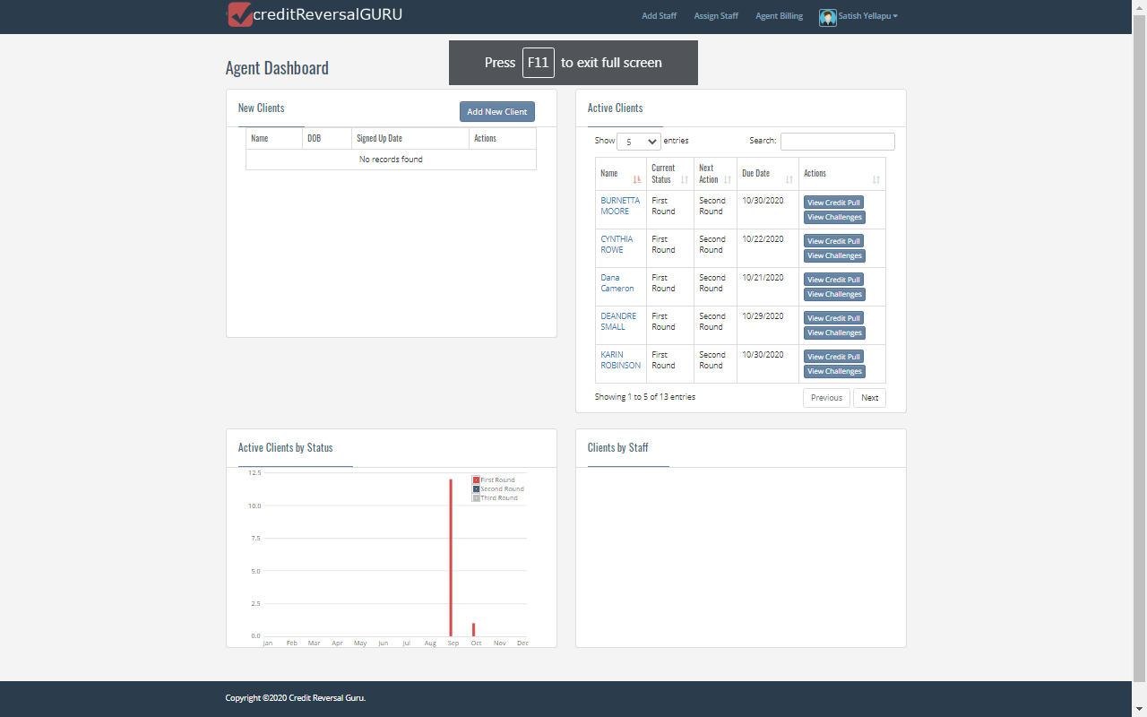

In the above screen if agent want to create new client then agent will click Add new client button then below Add new client page will be displayed

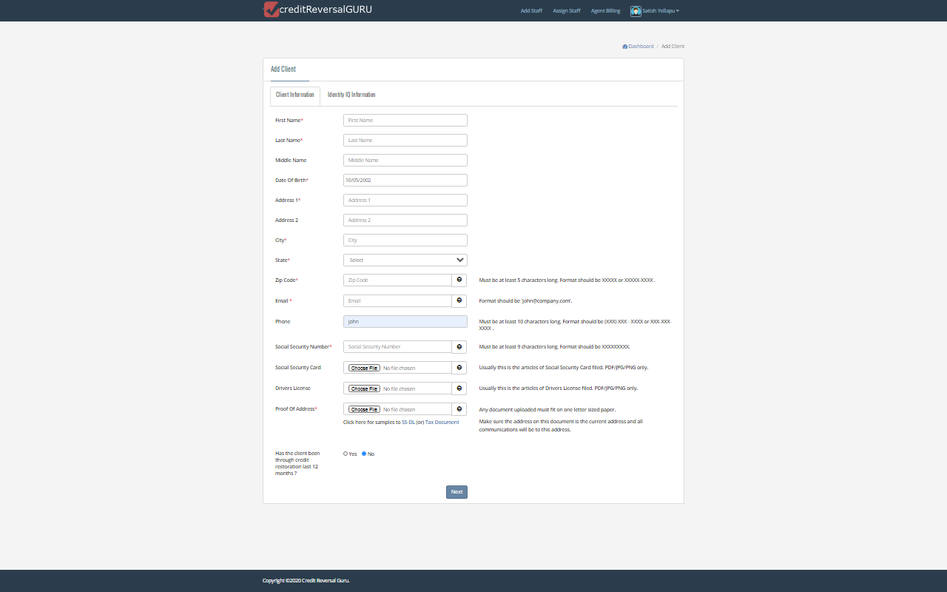

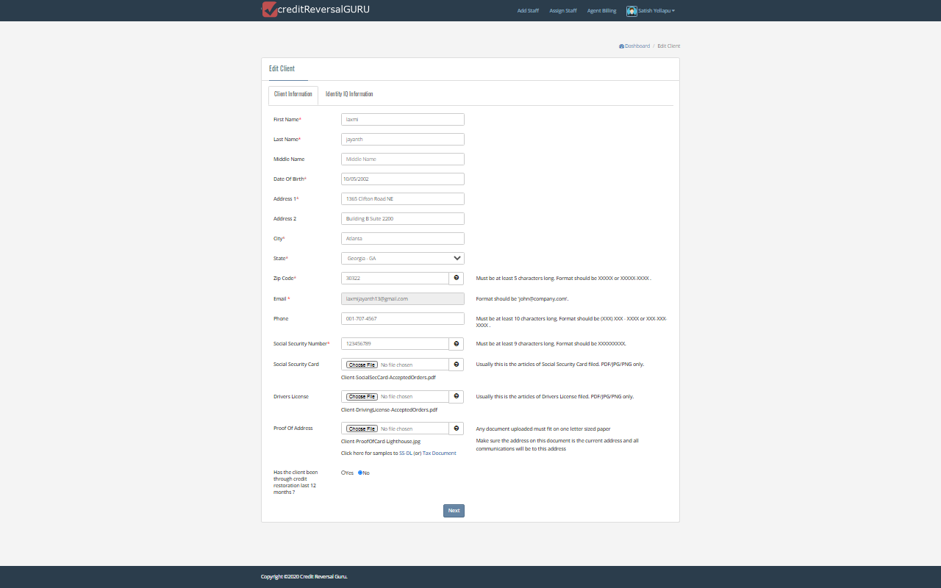

Here in the above screen we can see agent enter client data and upload required files needed to create new client here we have to note one thing beneath in the above page we can see “Has the client been through credit restoration last 12 months ?” here if agent click yes button for the statement then 2 nd round level challenge text will be displayed in the view challenges pdf file and if agent click no button then 1st round challenge text will be displayed in the view challenges pdf file and if agent click next button then IDENTITY IQ information page will be displayed that we can see in the below screen shot.

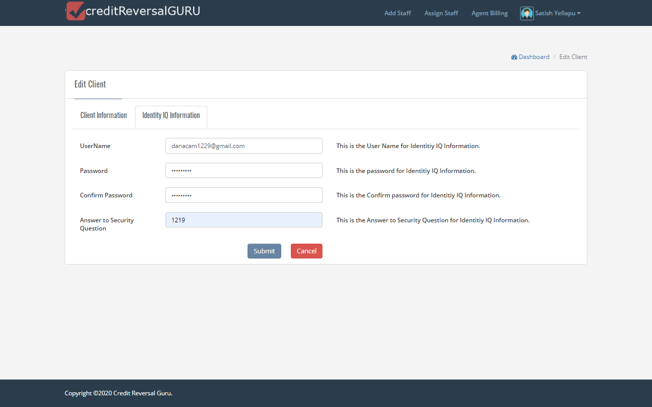

Here in the above screen if agent enter Identity IQ information and click submit button then created client wil be displayed near New Client in the agent dashboard page

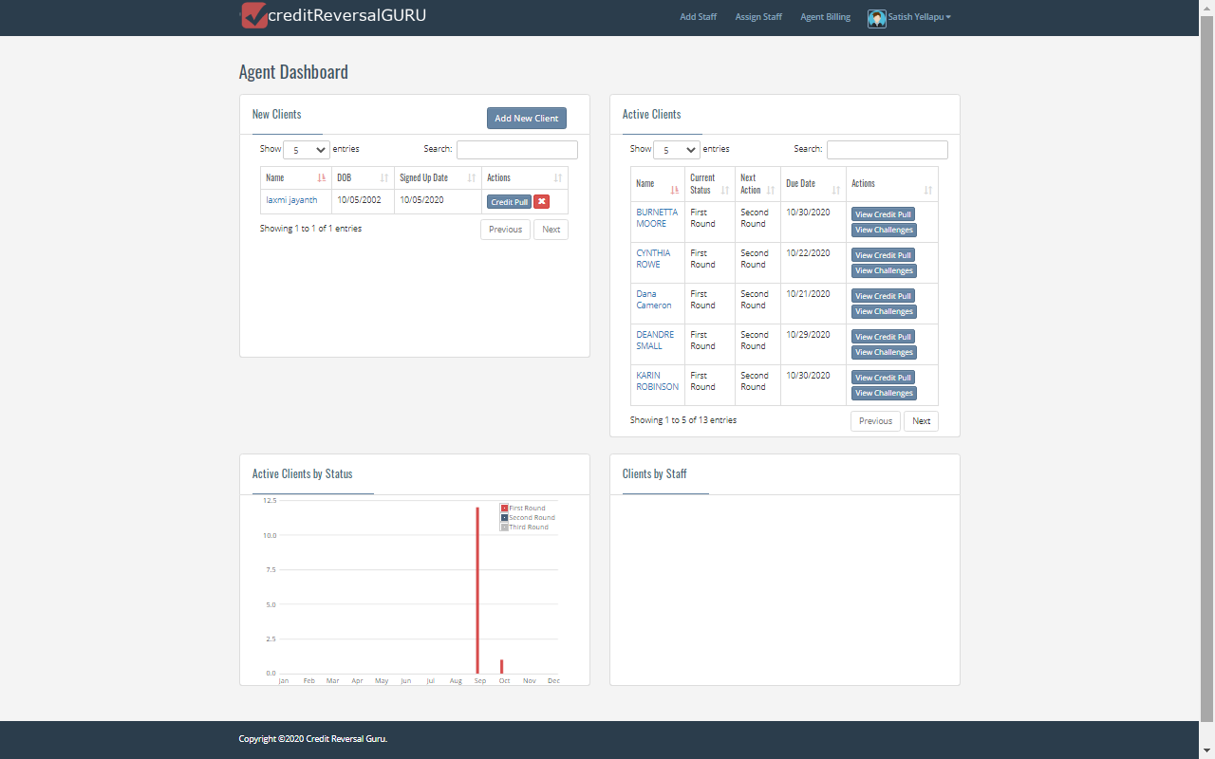

Here we have to note one thing if agent create client without entering Identity IQ information then Complete setup button will be displayed near new client in agent dashboard and if client enter client information and Identity IQ information then Credit Pull button will be displayed neat new client in agent dashboard page.

If agent click Complete setup button then Identity IQ information page will be displayed and once agent enter data in Identity IQ information and click submit then Credit pull button will be displayed instead of complete setup button under new clients in agent dashboard page

If agent click Credit pull button then below client credit items page will be displayed that we can see in the below screen

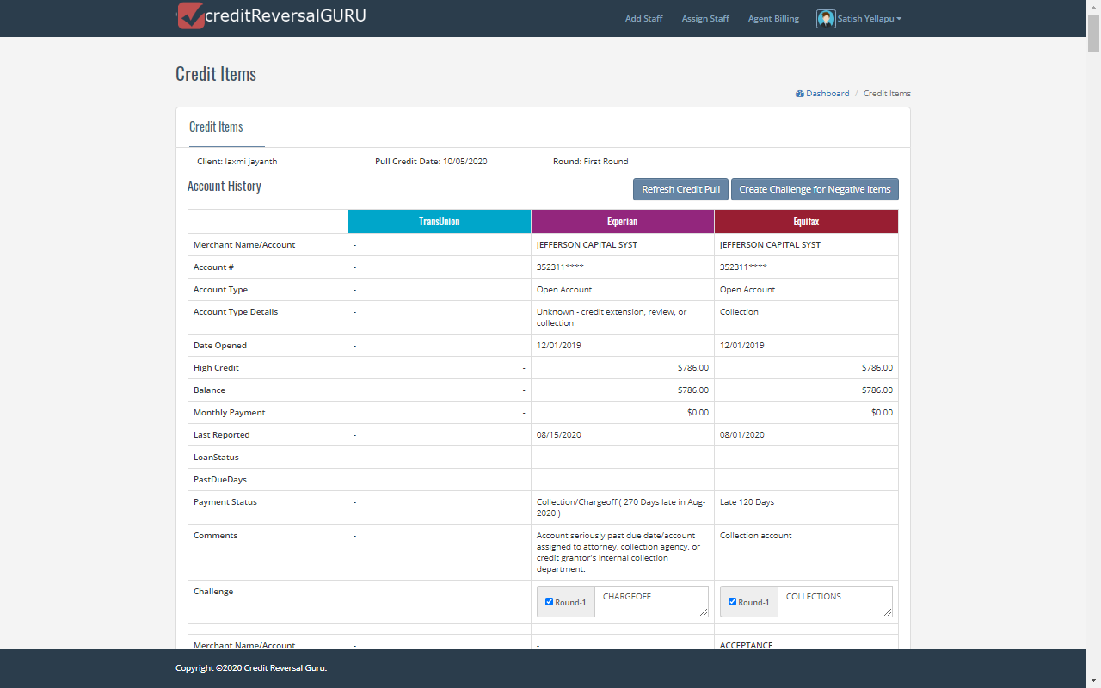

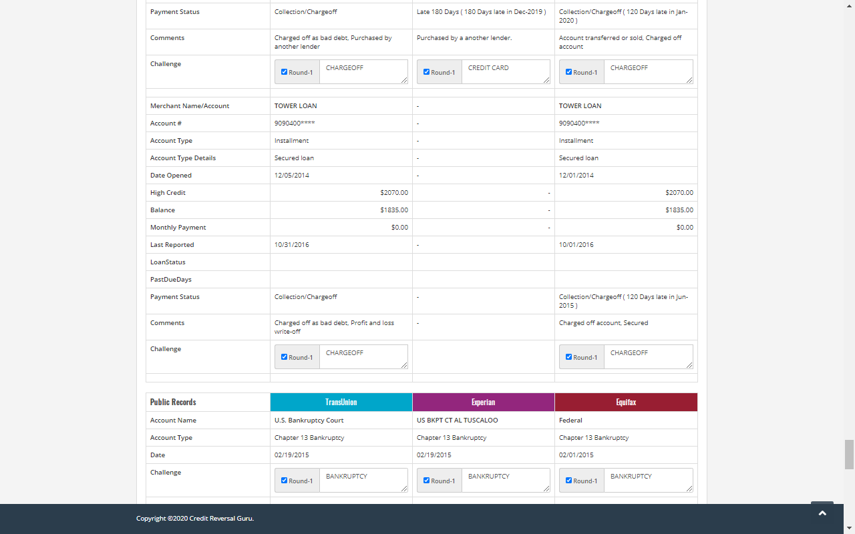

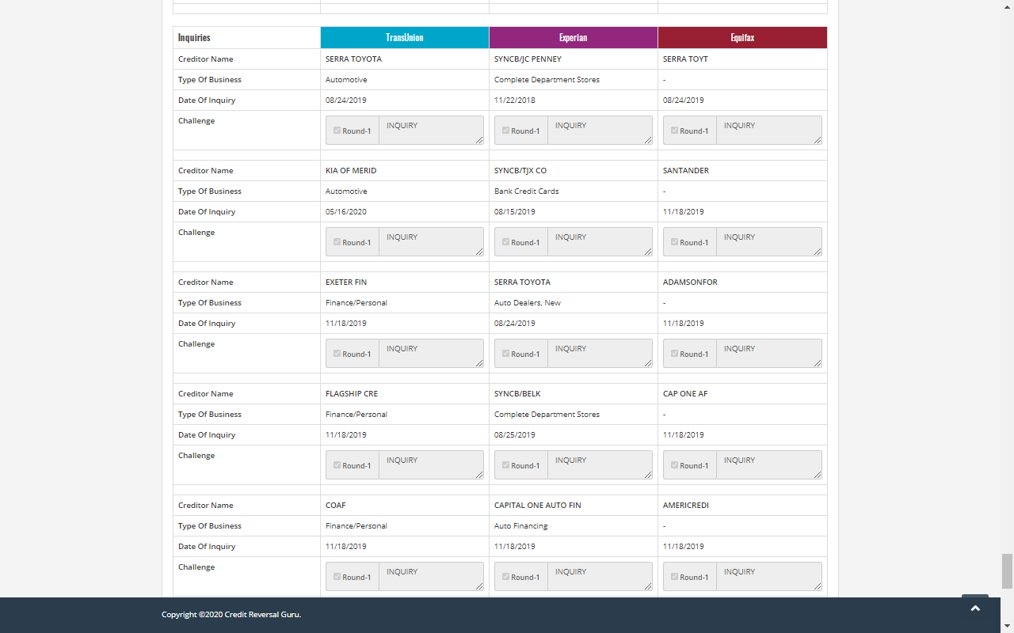

Here in the above client credit items page we can see client name , credit pull date and rounds will be displayed and in prior to that client account history data , Public records data and inquires data will be displayed and here in account history , public records and inquires, agent will click check box and enter data in text box in all the required fields and click Create for challenge items button then pop up message will be displayed showing success and ok button that we can see in the below screen

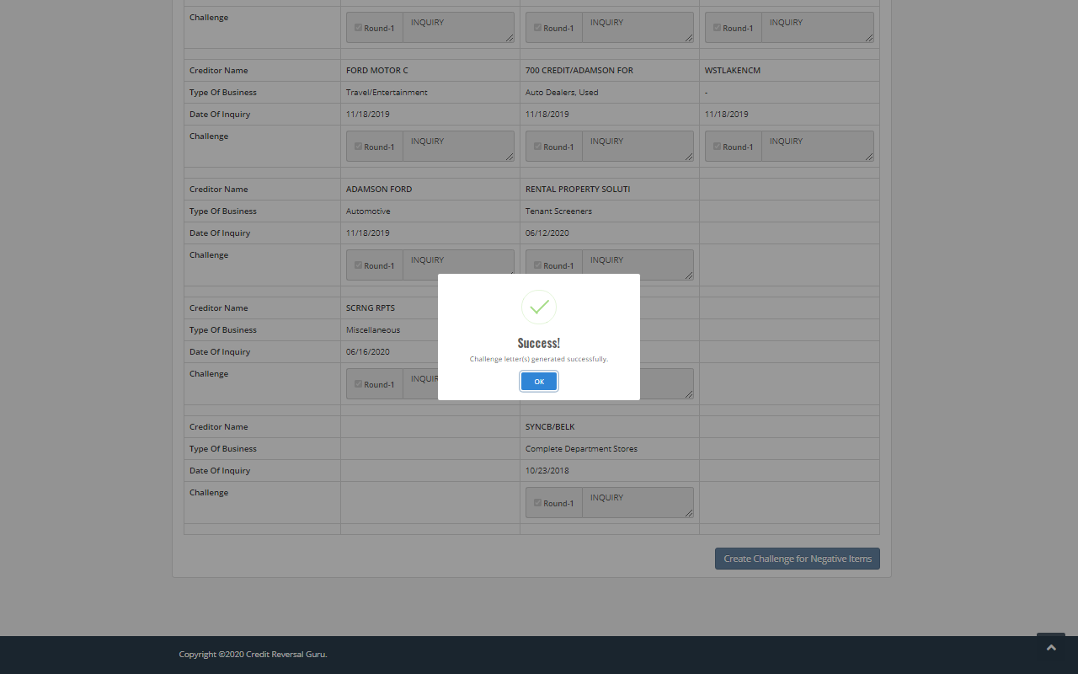

Once agent ok button in the success pop up message then client data will be displayed in the active clients list in agent dashboard page that we can see in the below screen

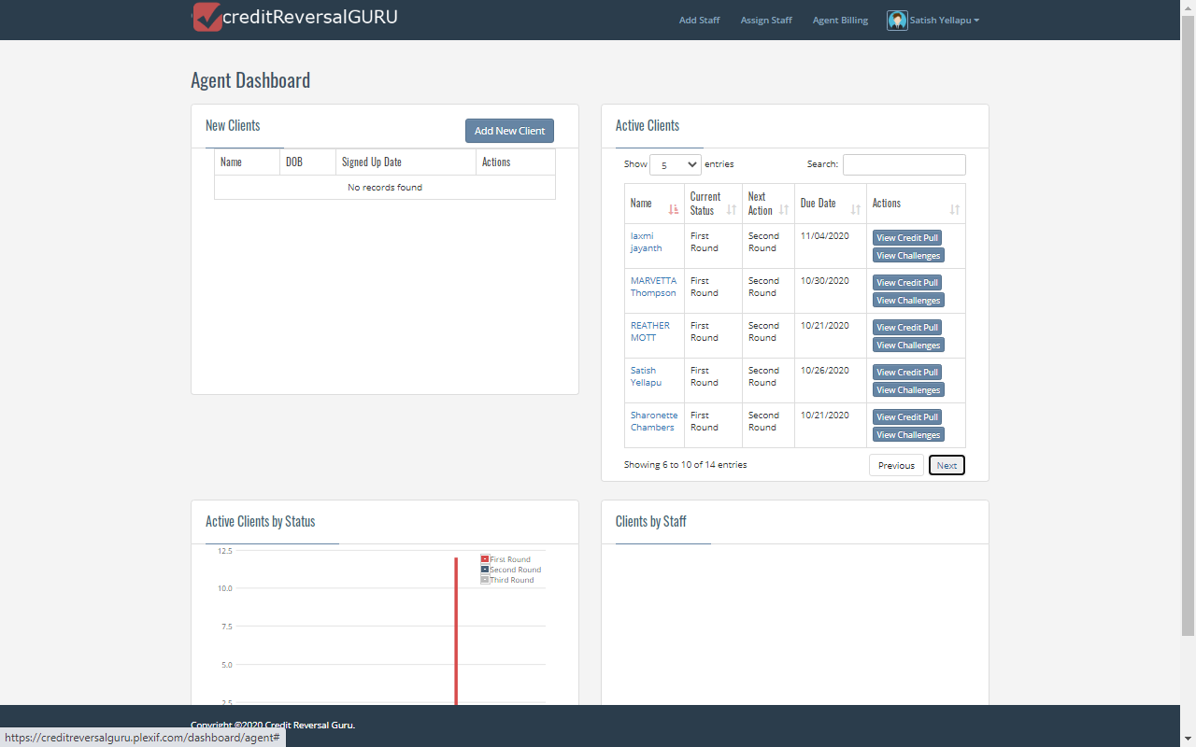

If agent click particular client view challenges button in active clients then challenges page will be displayed and we can see client s first round challenges text will be displayed

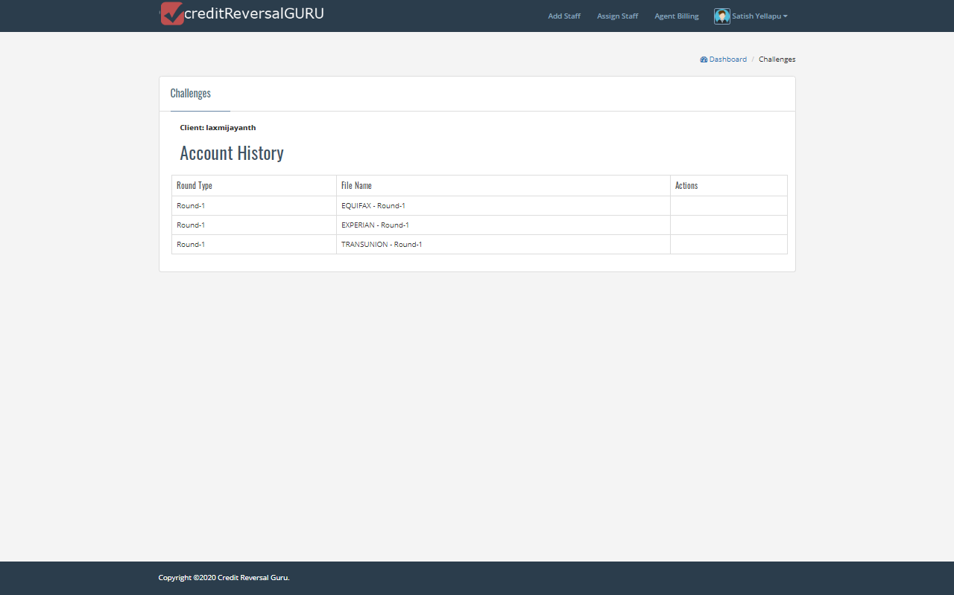

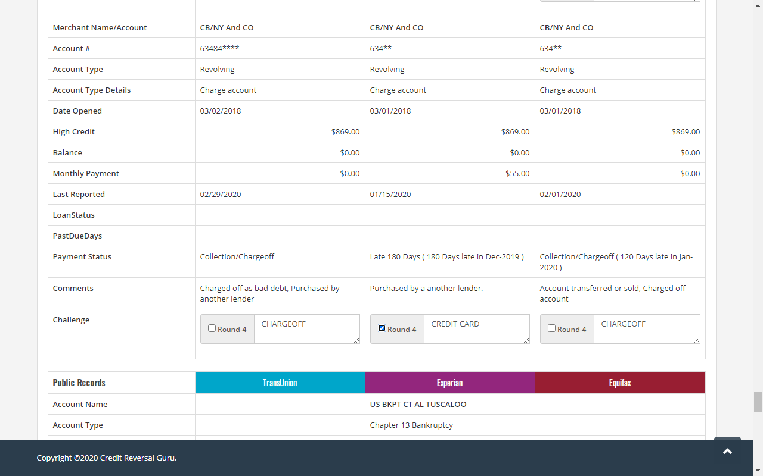

Here in the above screen in second round if agent want to uncheck any merchant check box in transunion , Experian or in Equifax and click create challenge for negative item then pop up message will be displayed that we can see in the below screen

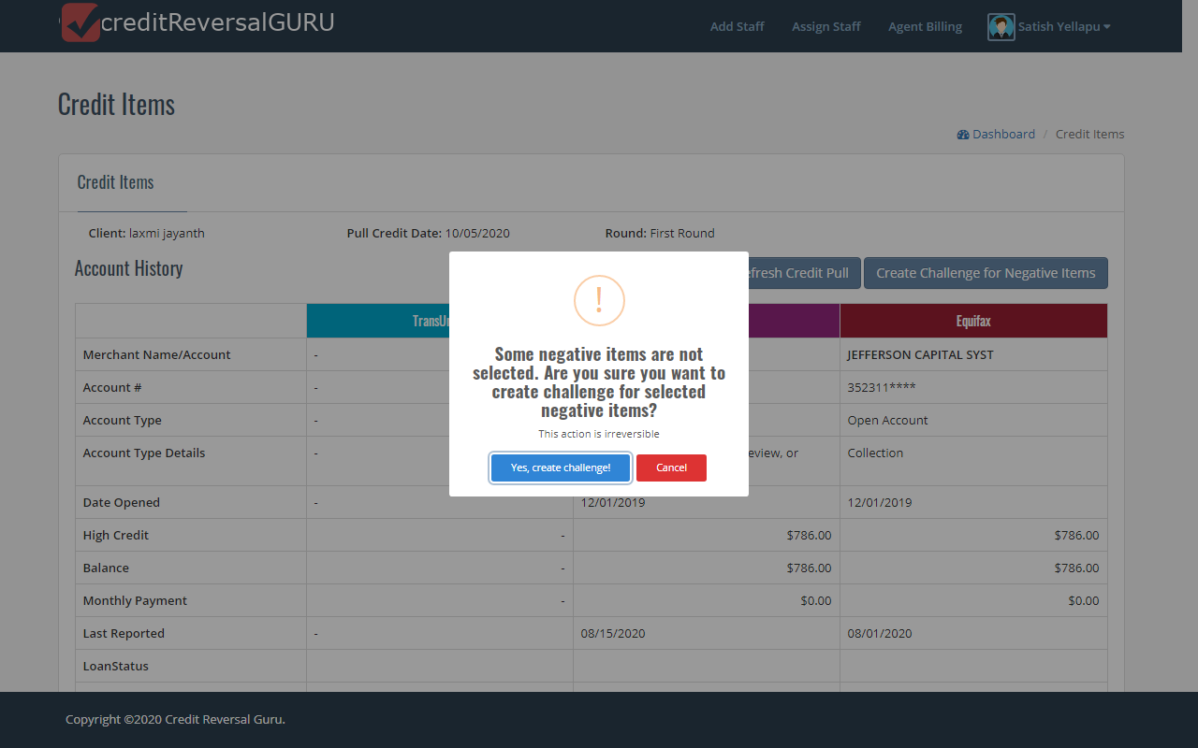

Here if agent click Yes create challenge button in the pop up message then one more pop up message will be displayed showing success that we can see in the below screen

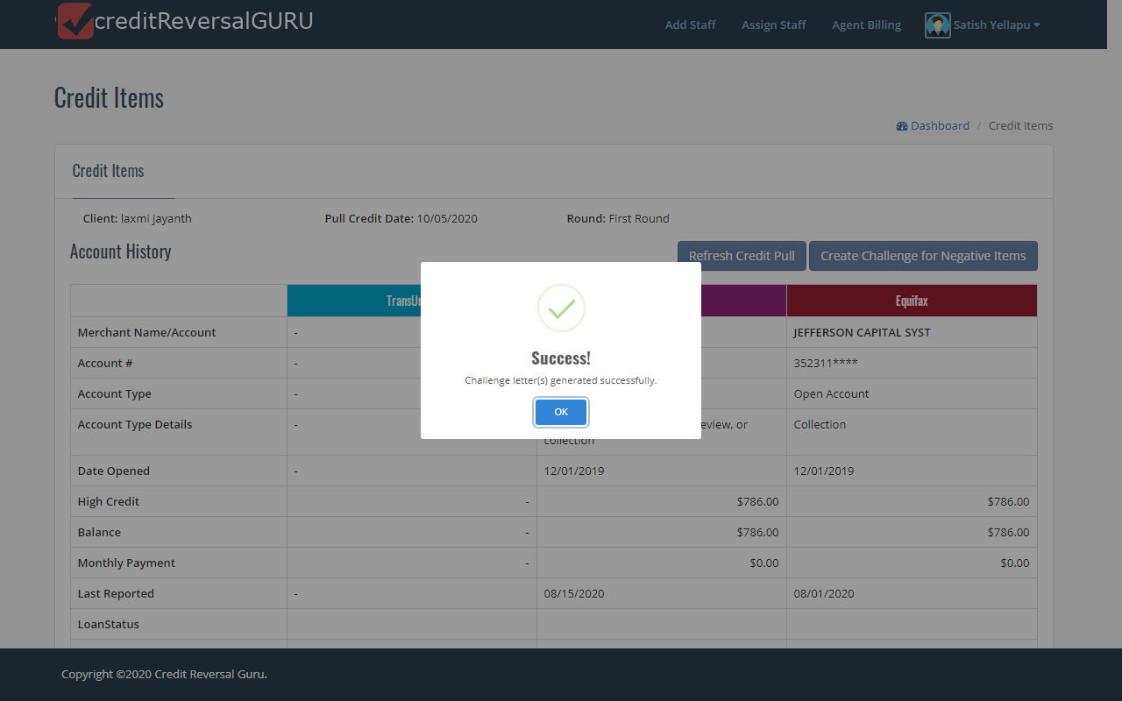

Once agent click ok button then all the unchecked merchant names in the credit items page will be deleted forever and will be not seen in further rounds that we can see in the below screen

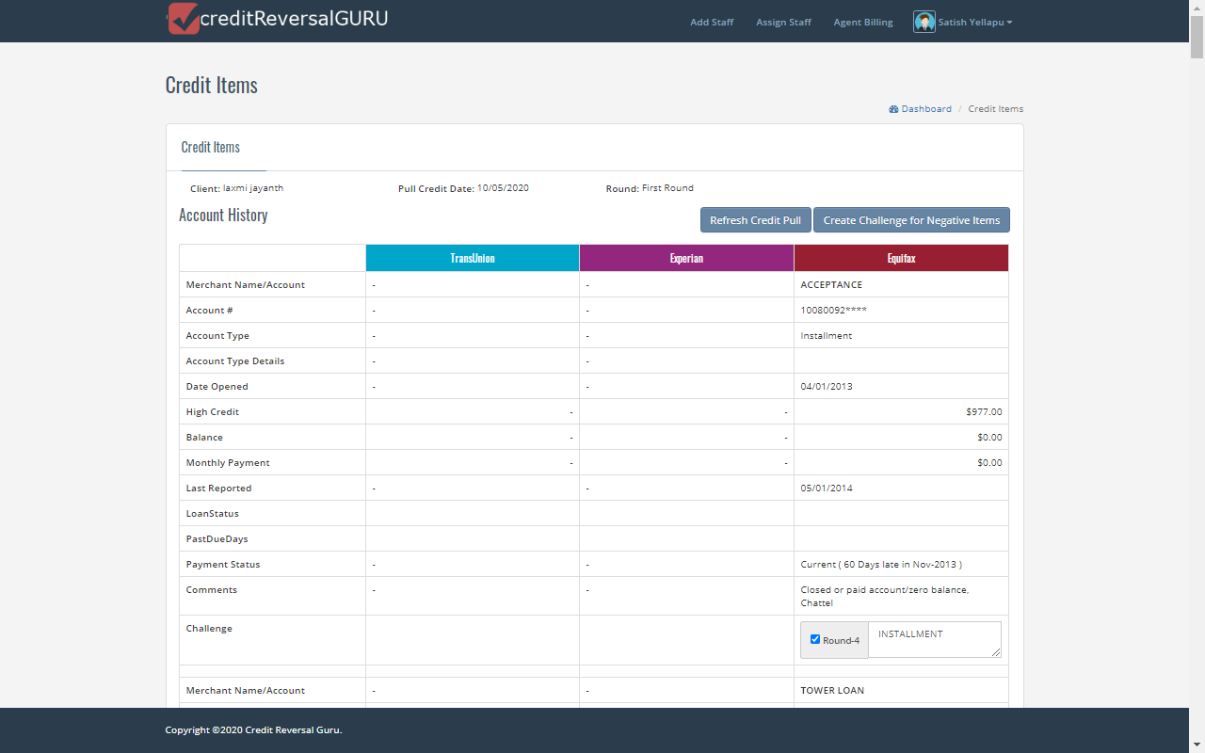

If agent click Refresh Credit pull mutton in the credit items page then pop up message will be displayed showing credit pull refreshed successfully that we can see in the below screen

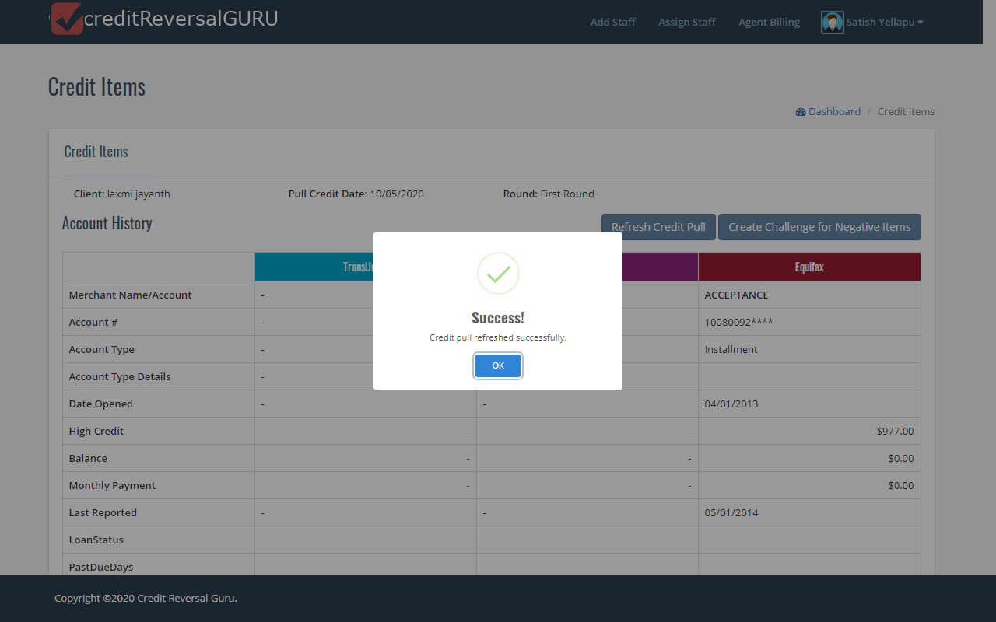

If agent click ok button in pop up message then below screen will be displayed showing refreshed credit item page

